February 2019 NEWSLETTER
ORLANDO PES/PEL/IAS JOINT CHAPTER

SPRING TUTORIAL: April 2, 9, 16, 23 2019 @ OUC Pershing - 5:45 PM to 9 PM
It’s time again for the annual Spring Tutorial, this year’s topics while still be developed may include:
- Project Management concepts including Scope Creep and Earned Value Calculations
- Power Plant Remediation’s
- Contracting Strategies
- Florida Transmission Line Siting Act
- Connecting a power plant under the FERC Open Access Transmission Tariff
- 10 – 12 PDHs towards your Florida License depending on the final topics

RSVP with DSLACK@OUC.COM to get your Jimmy John Sandwich. Order form on the last page.

Directions to Pershing is on the next page!
Cost
$120 For IEEE Members
$150 For Non Members
Free for Student IEEE Members
$30 Student Non Members

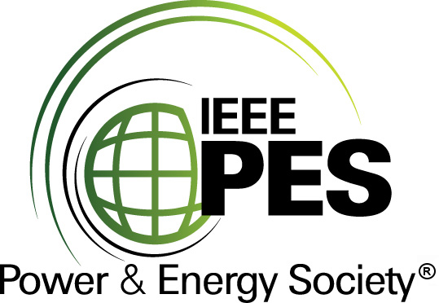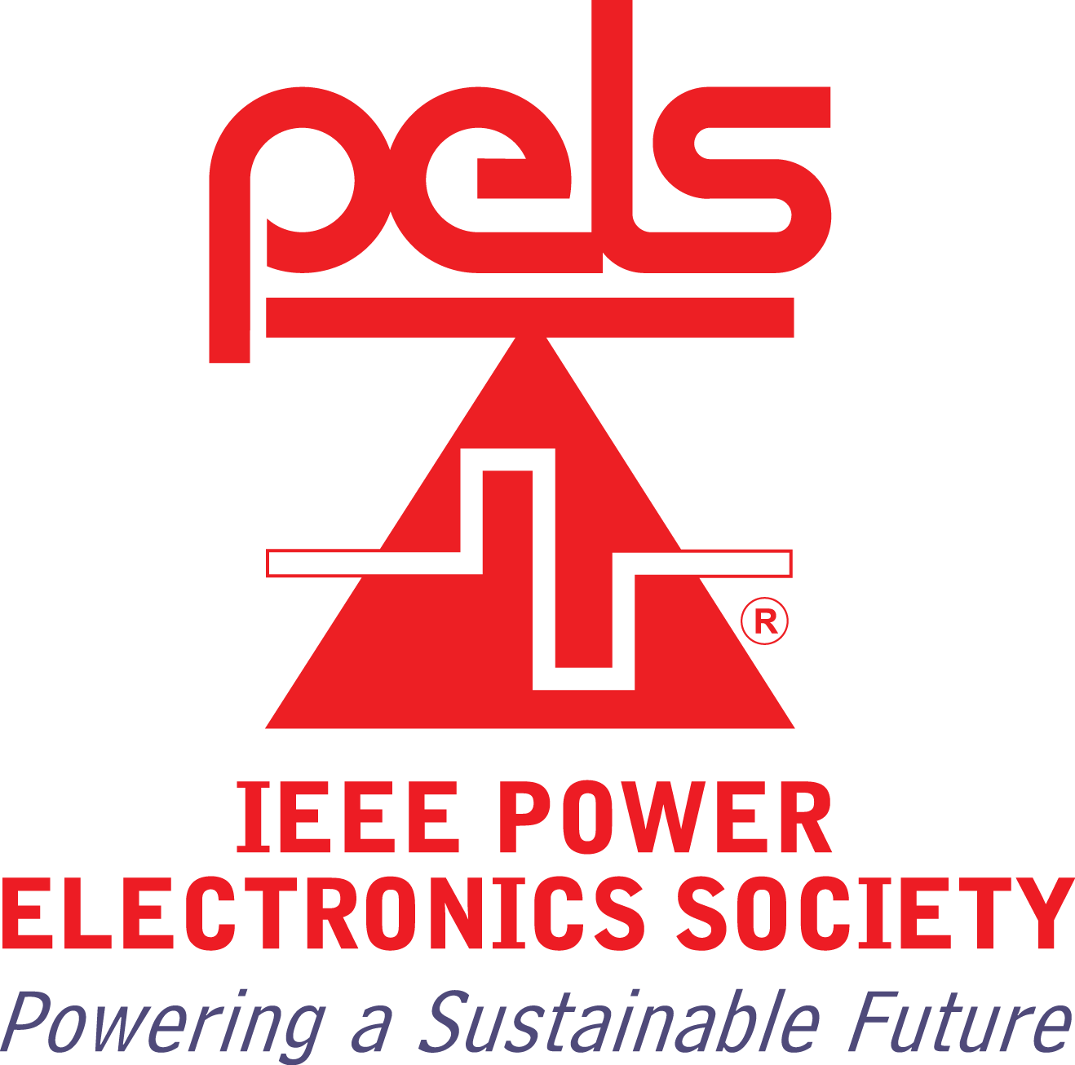
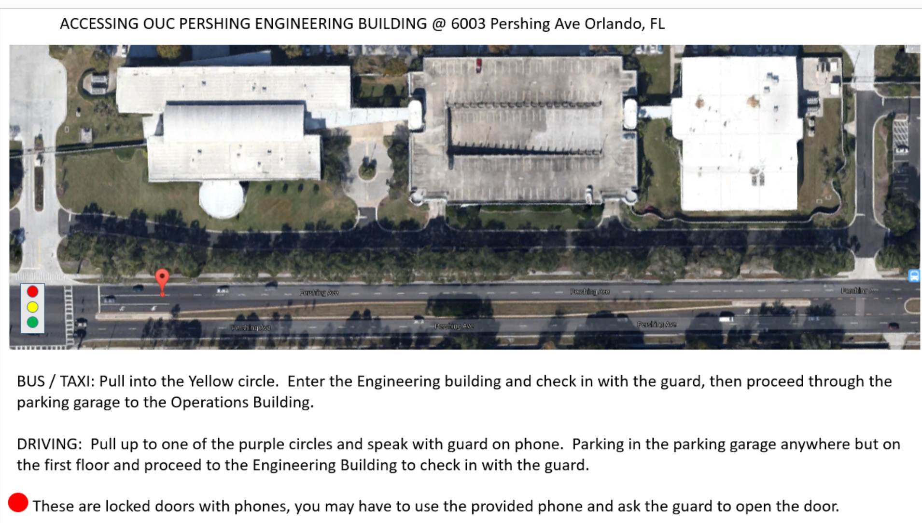

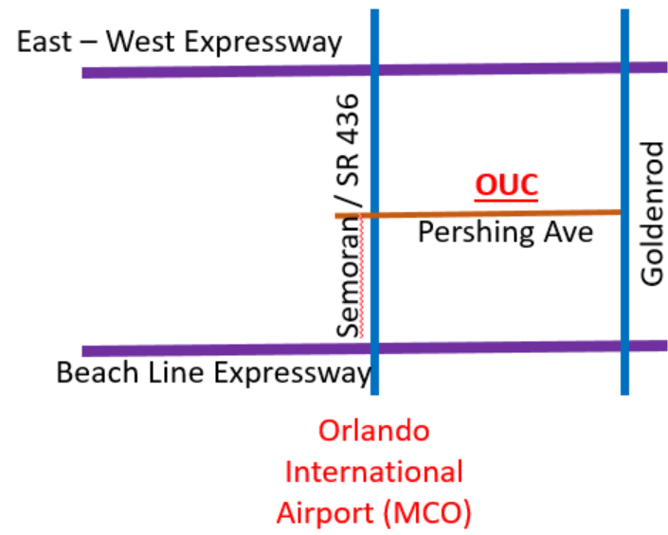
JIMMY JOHNS MENU: https://www.jimmyjohns.com/downloadable-files/jj_menu_no_prices.pdf

Please send the following information in an email to DSLACK@OUC.COM

If you plans change please remember to cancel your RSVP.

NAME: _______________________________________

SANDWICH BREAD: _______________________________

SANDWICH TYPE: ________________________________

EXTRA COMMENTS: (condiments/veggies to add or remove, extra meat/cheese)

_____________________________________________________________

________________________________________________________________

Please note the chapter provides Chips, Drinks and Deserts, so please just order the Sub.

EXAMPLE:
“Hey Dan I’m coming to the meeting!”

Name: Aaron Staley
Sandwich Bread: 9 Grain Hand Sliced Wheat
Sandwich Type: Perfect Italian
Extra Comments: Please add Cucumbers

